Variance: 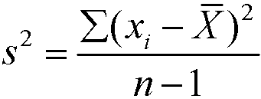 b1 =r*(Sy/Sx)

Covariance: 

Covariance: COV= Sum of all Xi,Yj((x− µX)(y −µY )p(x, y)

Correlation: Sxy/(Sx*Sy)

**PORTFOLIOS:**

Smean=aXmean+bYmean (a and b are weights)

Portfolio Variance: S^2=a^2*Sx^2+b^2*Sy^2+2ab[sxy]

0.8<r<1, -1<r<-.8 strong linear relationship

.5<r<.8, -.8<r<-.5 Moderate

-.5<r<.5 weak

Beta=slope of regression between stock’s rate of return

and return for the market as a whole

Beta>1 aggressive

Beta<1 defensive

Beta around1= neutral

**Probability rules:**

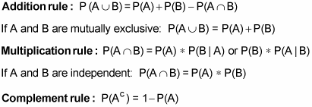

P(AandB)=P(a|b)*P(B)

## Probability definitions



RANDOM VARIABLES:

E(x)=sum(x)*P(X=x)

Var(x)=sum((X-mean)^2*probability)

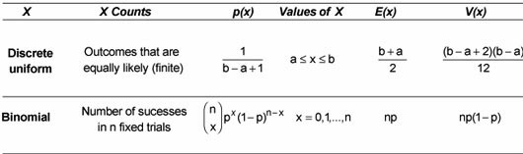

BINOMIAL:

P(all)=p^n

P(none)=(1-p)^n

P(at least 1 happening)=1-(1-p)^n

P(at least 1 not happening)=1-p^n

EMIPRICAL RULE: **68.27%–95.45%–99.73% rule**

Chebyshev’s inequality says that at least 1-1/*K*2 of data from a sample must fall within *K* standard deviations from the mean, where *K* is any positive real number greater than one.

Decision theory: just do e(x)

